05 Retention Pruning
Showing backups
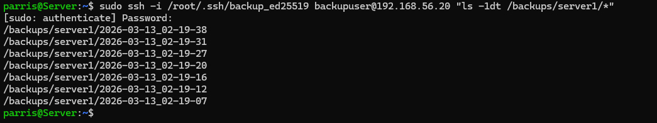
Script Removes old adds new backups
Keeps up to seven backups
06_checksums
Checksums file is present in backups
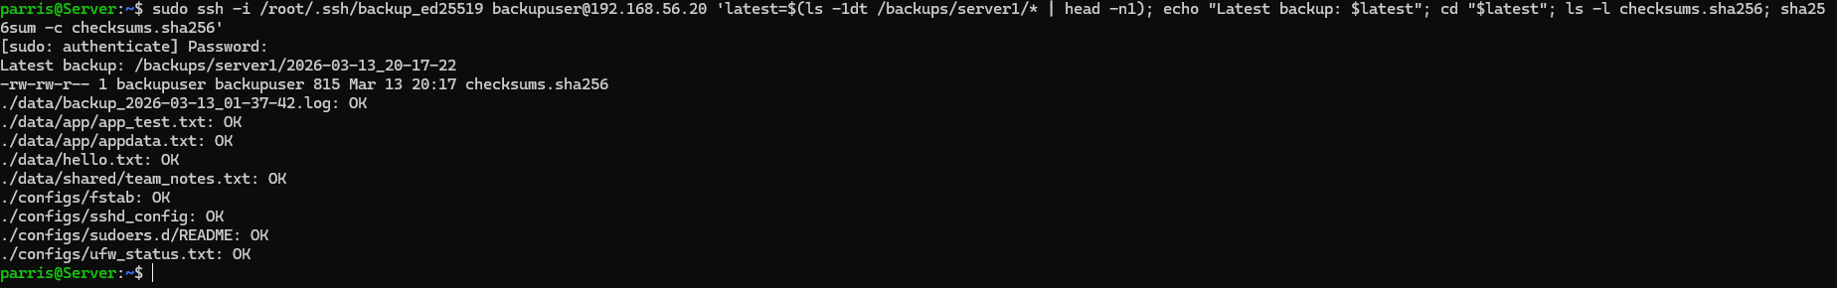
07_recovery
Showing file
Reading text in file
Hash for the file
Deleting the file
08_recovery
Showing the latest backup available
Restoring from that exact backup
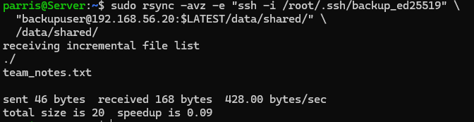
09_recovery verification
Showing that the file is restored
Reading file
Same file

